

**BAHRIA UNIVERSITY (KARACHI CAMPUS**)

ASSIGNMENT # 2 – FALL SEMESTER – 2022

Computer Communication and Networks (CEN-223)

Class: **BSE-5B** Submission Deadline: **29/11/2022**

Course Instructor: **Engr. Mahawish**  Max Marks: **05 marks**

Question 1**:** [CLO 5]

1. Draw a hybrid topology with a star backbone and three ring networks using 5 hosts in each ring topology.
2. Design a hybrid topology for a given classroom where each student is the host and the teacher is the central controller.

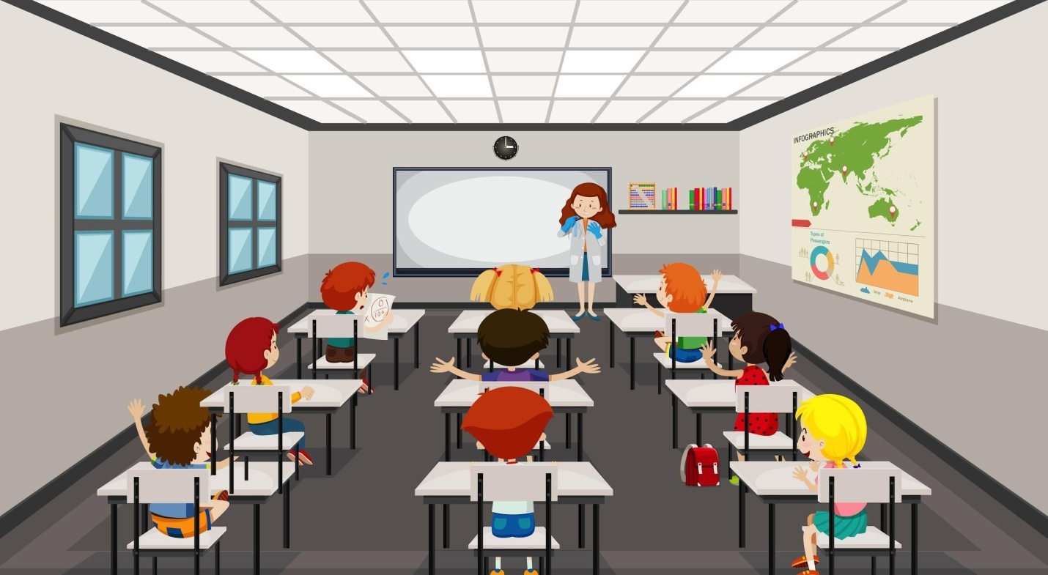

Scenario #1: IP Allocation in a MAN

You are tasked by your supervisor with assigning IP addresses for your new MAN

(Metropolitan Area Network), which consists of 8 different buildings, each building will have

255 workstations. Your supervisor tells you to only use as much of the 164.10.0.0 network

as you need. Your supervisor will assign the IP addresses to the serial interfaces using a

different network. You will need to determine the following four items for each of the eight

buildings:

A) Subnet masks

B) Network addresses

C) Broadcast address for each subnet

D) Valid host ranges on each subnet

Scenario #1: IP Allocation in a MAN

You are tasked by your supervisor with assigning IP addresses for your new MAN

(Metropolitan Area Network), which consists of 8 different buildings, each building will have

255 workstations. Your supervisor tells you to only use as much of the 164.10.0.0 network

as you need. Your supervisor will assign the IP addresses to the serial interfaces using a

different network. You will need to determine the following four items for each of the eight

buildings:

A) Subnet masks

B) Network addresses

C) Broadcast address for each subnet

D) Valid host ranges on each subnet

Scenario #1: IP Allocation in a MAN

You are tasked by your supervisor with assigning IP addresses for your new MAN

(Metropolitan Area Network), which consists of 8 different buildings, each building will have

255 workstations. Your supervisor tells you to only use as much of the 164.10.0.0 network

as you need. Your supervisor will assign the IP addresses to the serial interfaces using a

different network. You will need to determine the following four items for each of the eight

buildings:

A) Subnet masks

B) Network addresses

C) Broadcast address for each subnet

D) Valid host ranges on each subnet

Scenario #1: IP Allocation in a MAN

You are tasked by your supervisor with assigning IP addresses for your new MAN

(Metropolitan Area Network), which consists of 8 different buildings, each building will have

255 workstations. Your supervisor tells you to only use as much of the 164.10.0.0 network

as you need. Your supervisor will assign the IP addresses to the serial interfaces using a

different network. You will need to determine the following four items for each of the eight

buildings:

A) Subnet masks

B) Network addresses

C) Broadcast address for each subnet

D) Valid host ranges on each subnet